**ICS press** 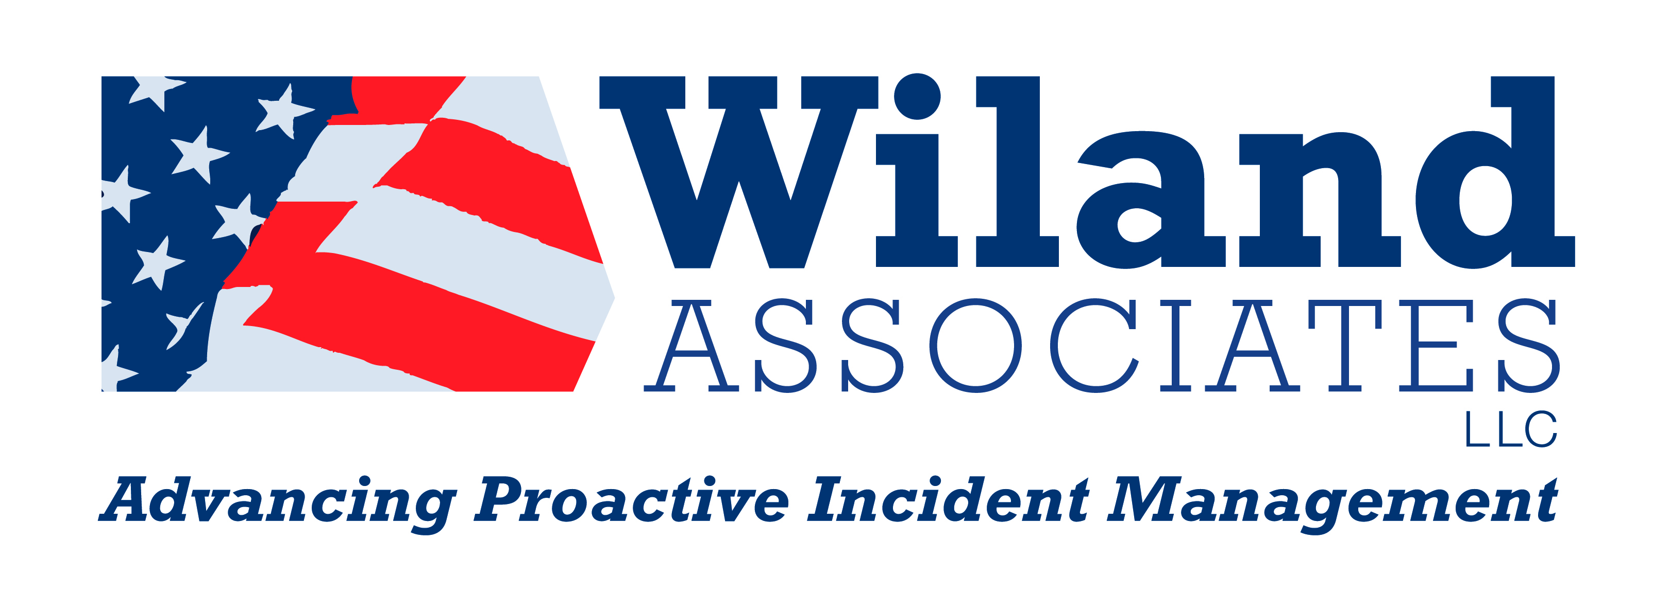 Monthly newsletter

Volume 1, Issue 1 July 2010

**WELCOME TO THE FIRST EDITION ICS PRESS!**



**In this month’s Issue of ICS Press**

* **Welcome from Kathy and Richard Andring.**
* **IMT member selection considerations**

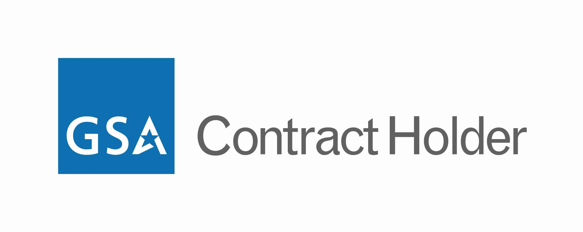

Willand Associates is in process of obtaining our GSA Contract. We will be on Schedules 874.

Interested in Free Certified Courses?

**Contact**

**Wiland Associates**

**for more information!**

509.697.9773

[ICSpress@WilandAssociates.com](mailto:ICSpress@WilandAssociates.com)

Check Us out on the Web

[WilandAssociates.com](http://www.wilandassociates.com)

**Wiland Associates**

Kathy and Richard Andring are pleased to present the first edition of the Wiland Associates ICS press. Our team has considered the idea of Wiland Associates publishing a quarterly newsletter for some time. And with the addition of new staff, we are now able to get it up and running

It is our hope that the ICS press will provide us another tool to communicate with those in our industry. As we grow the newsletter, our intention is to provide you with the following information:

* Introduction to new instructors and snapshot of their extensive background.
* The latest information regarding National Incident Management treads and initiatives.
* The latest on what is happening at Wiland Associates.
* A list of upcoming courses and availability.
* Information about ongoing incidents.
* Lessons learned by instructors and you.

If you have ideas, information or resources that you would like us to consider adding to this newsletter, please let us know. We are happy to be able to provide you with this new information and resource.

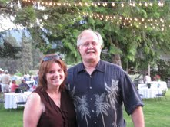

**ICS press**



**IMT Member Selection Considerations**

When selecting an Incident Management Team (IMT), there are many aspects to consider in advance. To help better prepare your team, we are willing to share some of our “trade secrets”. If you are willing to spend some valuable time up front learning short cuts, valuable lessons, and addressing small problems, you will have better results and can eliminate friction along the way. This article addresses how to best select those members of the IMT to create a winning combination.

It is critically important for an IMT to be successful every time that they are deployed and the pressure that coincides with that success is immense. To understand how to select your team, it is first important to contemplate the IMT’s work environment. We need to anticipate the working conditions into which IMTs are placed. The work environment is stressful, demanding, fast-paced and noisy. To compound those issues, IMT members often get little sleep and are exhausted. In addition, we must decide on solutions to problems that have no good answer. Because of these characteristics of the IMT working environment, and others, we need to set ourselves up for success by avoiding predictable behavioral characteristics among team members that will detract from our success and make our already difficult work even more challenging.

When selecting your IMT team, here are six considerations and questions that you should ask yourself about the potential candidates?

Being an "all-star" in our daily work does not mean that an employee will be a successful part of an IMT. A leader in our agency might win awards for single-handedly developing programs or leading his or her part of the organization, but independent action and singing solo are not positive attributes among IMT members. If such a person can also "fall in" and work as a member of the team, being part of something larger than himself, and subordinating herself to the needs and mission of the IMT, then he or she can be a successful member. It would be wise to look for candidates who have demonstrated that they can be a team member; solo heroism should not be worth points in the IMT selection process. Can the candidate put team-work above their own personal need for autonomy?

When time and tempers are short, how does the candidate interact with others? Are comments and behavior appropriate? Do they contribute to, or detract from the team's success? Do they have the social situational awareness (also known as "Emotional Intelligence") to speak up when the team needs to hear from them and to remain silent when they do not? Do they occupy the team's time with a conversation that should involve only two people?

Does the candidate follow the Planning Process, meet deadlines, and submit the best possible work under the circumstances? Straying from these expectations makes life unnecessarily difficult on the rest of the team.

How does the candidate handle stress and adversity when things aren't going well, when fatigued, overworked, or insulted? Does he or she offer assistance, encouragement, or forgiveness when those are called for? Can the candidate lighten a stressful load by making the endeavor fun and enjoyable (perhaps by using a sense of humor that is appropriate in the workplace)?

Continue article on page 3

**Kathy and I are frequently asked how we came up with the name Wiland Associates. It's a long story, but I will keep it short. Kathy's maiden name was Wilson and as you can see, we merely took the first three letters of her maiden name, attached them to the first three letters of mine, and there you have it: "Wiland" -not to be confused with wild land.**





Click here for more Wiland Q&A

**www.WilandAssociates.qhub.com**

continued from page 1

Does the candidate put on his "game face" and conduct himself in a professional and dignified manner when that is called for? How does he or she represent the team and the host agency when being observed (and evaluated) by responders, the media, citizens, and victims?

Does our potential team member have the desire to participate? Desire for success is an essential element that will help our team overcome the obstacles that are always a part of incident management. And do they do this with the dignity, maturity, and professionalism that is needed?

By considering the above information and asking yourself these questions, it may be that you will miss out on exceptional strengths that an individual would bring to your team. However, individual strength is not as important as the strength of the team. Our best team members may not be the folks who are our tactical all-stars day in and day out. They may not be our stand alone heroes. Instead, a better candidate could be the hard-worker who is dependable, mature and can successfully fill the role they are given. The most important role is to contribute to the strength of the team.

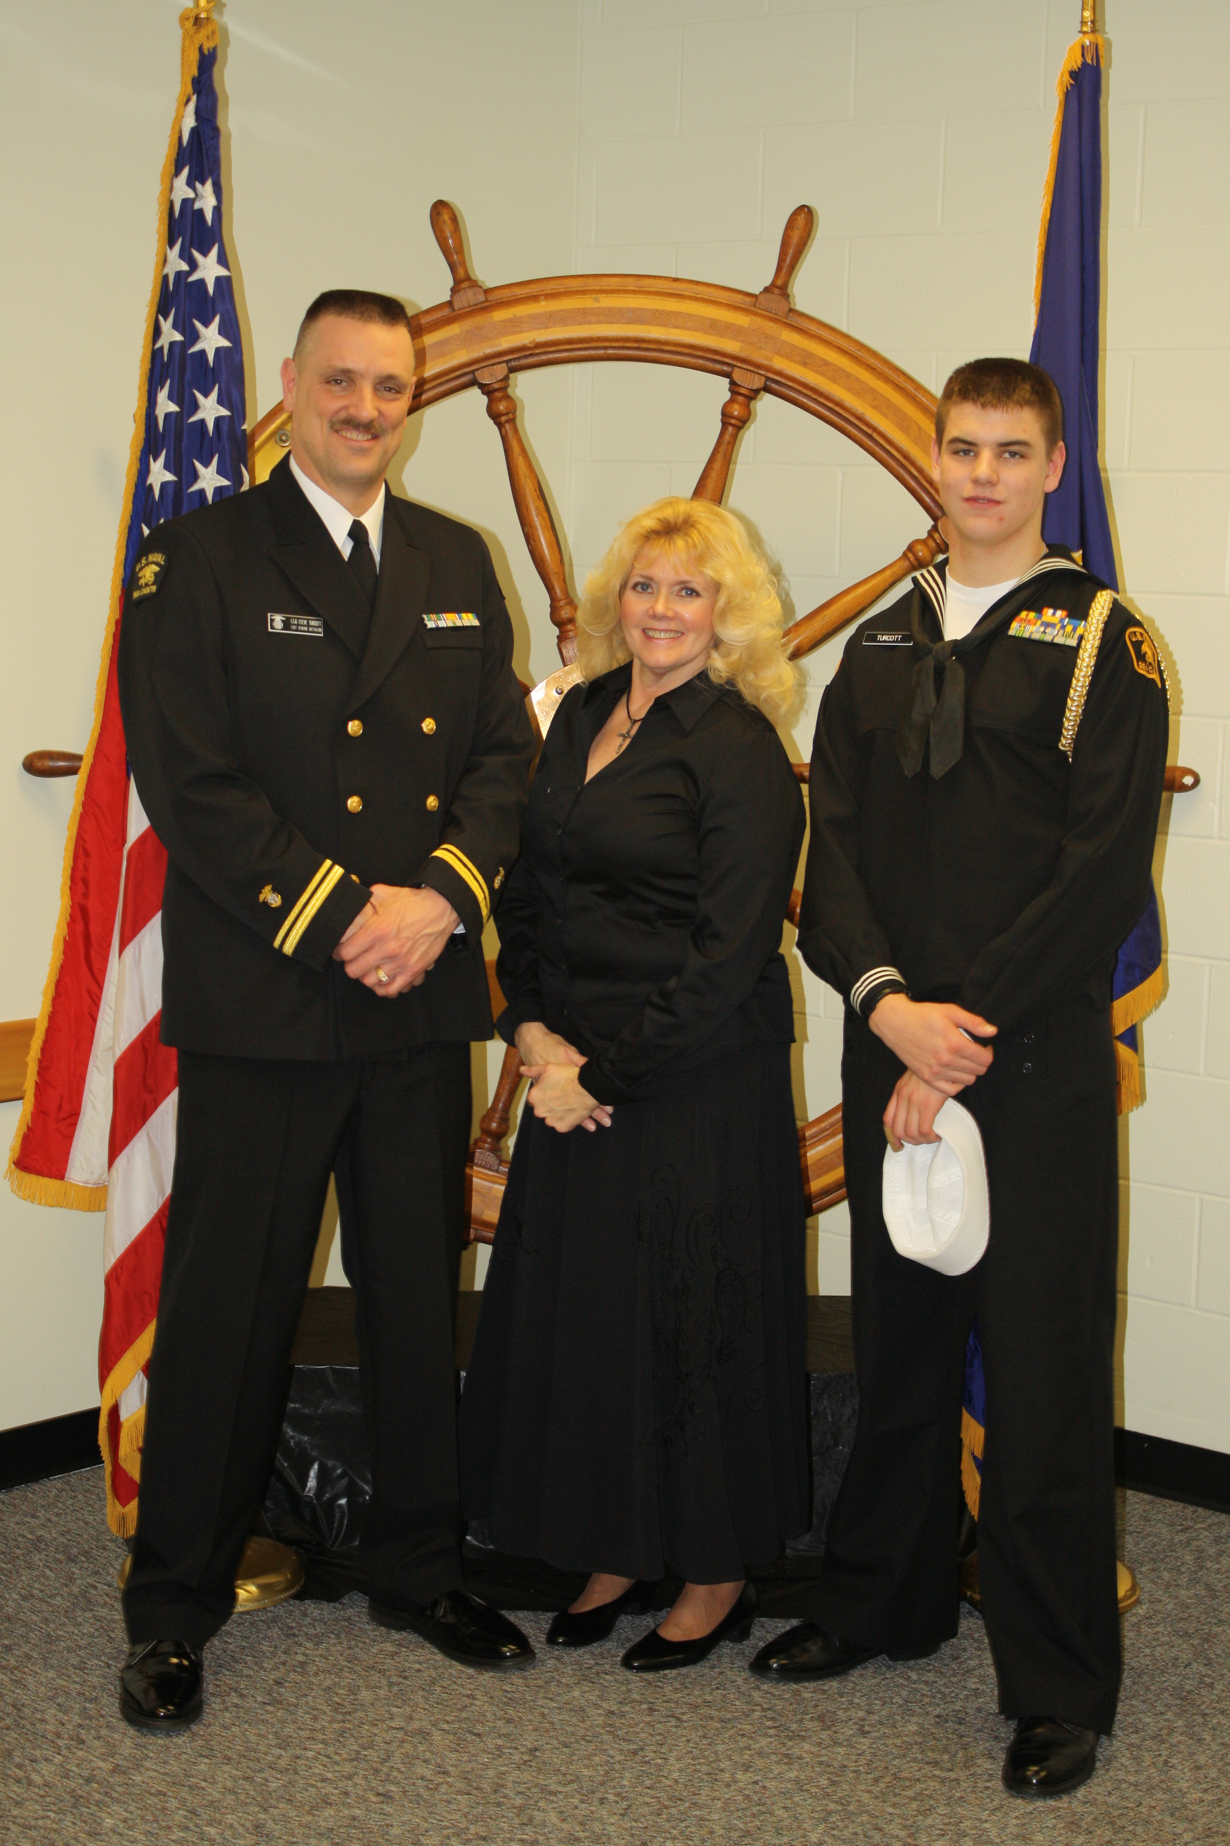

**By: Steve Turcott**

**Washington State Patrol**

**Have any newsletter topics or ideas?**

**We would love to hear from you.**

**Please post a message on our blog or shoot us an email.**





**Wiland Associates LLC**

**1651 Collins Road, Selah WA 98942**

**509.697.9773**

**info@WilandAssociates.com**

**Next Month’s Newsletter**

**News from the Gulf**

**&**

**Where to find highly-qualified**

**IMT members**

continued from page 2